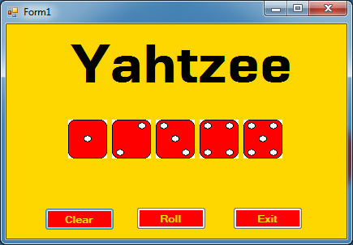

Private Sub btnClear_Click(sender As System.Object, e As System.EventArgs) Handles btnClear.Click

picDice1.Image = picFace1.Image

picDice2.Image = picFace2.Image

picDice3.Image = picFace3.Image

picDice4.Image = picFace4.Image

picDice5.Image = picFace5.Image

End Sub

Private Sub btnRoll_Click(sender As System.Object, e As System.EventArgs) Handles btnRoll.Click

Dim d1 As Integer = Rnd() * 6 + 1

Dim d2 As Integer = Rnd() * 6 + 1

Dim d3 As Integer = Rnd() * 6 + 1

Dim d4 As Integer = Rnd() * 6 + 1

Dim d5 As Integer = Rnd() * 6 + 1

'Dice1'

If d1 = 1 Then picDice1.Image = picFace1.Image

If d1 = 2 Then picDice1.Image = picFace2.Image

If d1 = 3 Then picDice1.Image = picFace3.Image

If d1 = 4 Then picDice1.Image = picFace4.Image

If d1 = 5 Then picDice1.Image = picFace5.Image

If d1 = 6 Then picDice1.Image = picFace6.Image

'Dice2'

If d2 = 1 Then picDice2.Image = picFace1.Image

If d2 = 2 Then picDice2.Image = picFace2.Image

If d2 = 3 Then picDice2.Image = picFace3.Image

If d2 = 4 Then picDice2.Image = picFace4.Image

If d2 = 5 Then picDice2.Image = picFace5.Image

If d2 = 6 Then picDice2.Image = picFace6.Image

'Dice3'

If d3 = 1 Then picDice3.Image = picFace1.Image

If d3 = 2 Then picDice3.Image = picFace2.Image

If d3 = 3 Then picDice3.Image = picFace3.Image

If d3 = 4 Then picDice3.Image = picFace4.Image

If d3 = 5 Then picDice3.Image = picFace5.Image

If d3 = 6 Then picDice3.Image = picFace6.Image

'Dice4'

If d4 = 1 Then picDice4.Image = picFace1.Image

If d4 = 2 Then picDice4.Image = picFace2.Image

If d4 = 3 Then picDice4.Image = picFace3.Image

If d4 = 4 Then picDice4.Image = picFace4.Image

If d4 = 5 Then picDice4.Image = picFace5.Image

If d4 = 6 Then picDice4.Image = picFace6.Image

'Dice5'

If d5 = 1 Then picDice5.Image = picFace1.Image

If d5 = 2 Then picDice5.Image = picFace2.Image

If d5 = 3 Then picDice5.Image = picFace3.Image

If d5 = 4 Then picDice5.Image = picFace4.Image

If d5 = 5 Then picDice5.Image = picFace5.Image

If d5 = 6 Then picDice5.Image = picFace6.Image

End Sub

Private Sub btnExit_Click(sender As System.Object, e As System.EventArgs) Handles btnExit.Click

Application.Exit()

End Sub

End Class